**ONLINE PHARMACY**

**15IT304J - WEB PROGRAMMING**

***Submitted by***

Vignesh Reddy – RA1711003010758

Rishika Kapoor – RA1711003011058

Krishna Teja - RA1711003011185

***In partial fulfillment of the requirements for the degree of***

## **BACHELOR OF TECHNOLOGY**

## 

**DEPARTMENT OF COMPUTER SCIENCE AND ENGINEERING**

# **FACULTY OF ENGINEERING AND TECHNOLOGY**

**SRM INSTITUTE OF SCIENCE AND TECHNOLOGY**

**KATTANKULATHUR- 603 203**

**Introduction**

Pharmacies are ubiquitous yet critical establishments which are often the first points of access to medicines. However, in India, the density of pharmacies is higher in urban areas than that in rural areas. Urban India has seen a transition from a traditional extended family to a nuclear family structure which has isolated the elderly and reduced their access to medicines; while, people living in remote villages are required to travel to nearby towns to access healthcare services. In addition, another major factor which directly impacts the access to medicines is the inability of the retail pharmacy to store a wide range of products, forcing the consumers to visit multiple stores for procuring all the specified medicines. Chronic conditions like diabetes, hypertension, etc. require patients to regularly use medications for the remainder of their lives. However, with limited access to medicines, the patient compliance levels get affected. Lack of access to continuing treatment is not only associated with poor health outcomes and/or premature death, but also impacts the economic growth of the country

**System Requirements**

1. Operating system: Windows (98, 2000, ME, NT, XP, Vista, 7, 8, 10), Linux, Mac OS.
2. JavaScript-enabled web browsers: Mozilla Firefox (most suitable), Internet Explorer, Google Chrome, and Opera-mini.
3. Database - SQL

4.Virtual Server: XAMPP server

**System Architecture**

**OPEN   
 WEBSITE**

**ACCOUNT ? NO**

**YES SIGNUP**

**LOGIN**

**ADD TO CART**

**FILL DETAILS**

**DO PAYMENT**

**ORDER PLACED**

**Description**

An online pharmacy, internet pharmacy, or mail-order pharmacy is a pharmacy that operates over the internet and sends orders to customers through mail, shipping companies, or online pharmacy web portal.

Online pharmacies offer better pricing than offline stores, with increased access, lower transaction and product costs, convenience, and greater anonymity for consumers. They offer accessibility to people with limited mobility and people in remote areas. These provide media alerts (personalized medicine reminder service), discounts, doorstep delivery within a short time, and validation of prescription through licensed pharmacists. Information about substitutes and adverse effects is also available on these sites. Consumers believe (perhaps rightly) that the medicines they receive from online pharmacies are comparable to medicines sold in the “brick-and-mortar pharmacies.”

Online pharmacy offers advantages and great ways for patients all across the world to have good medication. Online pharmacy also provides immediate information that a patient needs. It is also cheaper compared to the traditional one. However, there are still disadvantages accompanied to online pharmacy when acquiring medication from it such as less accuracy in diagnosis and the big chances of having a wrong prescription. In addition to that, there are also some ethical dilemmas that an online pharmacy experience today. This includes the issue about the assurance of the patient or customer upon acquiring the medication they need as it undergoes proper importation rules.

**Working**

1. The new user can signup to the website. Fill the desired feilds, and then you will be redirected to the login page.
2. Home page appears, you can choose your item and can proceed.
3. On the home page, you can also view to the new offers that are updated.
4. If you don’t know the medicines, then you can also upload prescription.
5. You can also look to the page to contact us.
6. The user can also get insights about us page, where they can get to know about the developer’s team.
7. Finally, as soon as user decides what items he/she wants , he can proceed to payment form
8. As soon as user fills all the details on that form he can click on **pay** button.
9. He will be redirected to the page, where his/her payment is done successfully.
10. In case, of any queries the user can contact us.

**Module Description:**

**1. Header and Footer**

Headers and footers generally contain additional information such as page numbers, dates, an author's name, and footnotes, which can help keep longer documents organized and make them easier to read.

In header various options are provided like home page button to access home page directly from any page on the site. Options like about us, special offers , is provided for the user to make it easy for them to access the site using navbar.

In footer the user is provided various options to make their experience more easier and smoother. User can have information can contact them on their mail or any other social media account.

Various html tags are used to develop the header and footer like head ,div, article , list etc. to make pages more attractive CSS and bootstrap elements are used like background color, font color etc.

**Technologies used :-**

* **HTML**
* **CSS**
* **Bootstrap**

**2. View Pages**

View Pages are basic implementation of HTML and CSS to design web pages for each of the website each view page displays over each category of online pharamacy The prices and other information is provided on the page.Various media tag elements are used to provide user with photos, videos.

**Technologies used :-**

* **HTML**
* **CSS**
* **Bootstrap**

**3. Signup/Login**

A signup page (also known as a registration page) enables users and organizations to independently register and gain access to your system. It is common to have multiple signuppages depending on the types of people and organizations you want to register.

**Password with JS validation**

In this technological age password hacking is at it’s tipping point so in order to make password more secure and not easily hack able there are some validation that needs to be full filled while assigning password to accounts.

1.Such as Password must contain number as well as alphabets. (Alphanumeric)  
2. First Name, Last Name and User ID should not be a part of Password.  
3.Both(password and confirm password) must match.

**Technologies used :-**

* **HTML**
* **CSS**
* **Bootstrap**
* **Php**
* **XAMP**
* **MySql**

**4. Booking Page**

Booking pages are the basis of Schedule Once's scheduling approach. They are pages through which bookings are made.

You can set up your Booking pages in different ways, based on your specific scheduling scenario. Each Booking page is completely independent in its settings. Booking pages can be used with or without [Event types](https://help.oncehub.com/help/introduction-to-event-types" \o "Introduction to Event types), and can be included in a [Master page](https://help.oncehub.com/help/introduction-to-master-pages" \o "Introduction to Master Pages). Booking page uses JS, HTML ,CSS ,PHP and MYSQL

PHP code is usually processed on a [web server](https://en.wikipedia.org/wiki/Web_server" \o "Web server) by a PHP [interpreter](https://en.wikipedia.org/wiki/Interpreter_(computing)" \o "Interpreter (computing)) implemented as a [module](https://en.wikipedia.org/wiki/Plugin_(computing)" \o "Plugin (computing)), a [daemon](https://en.wikipedia.org/wiki/Daemon_(computing)" \o "Daemon (computing)) or as a [Common Gateway Interface](https://en.wikipedia.org/wiki/Common_Gateway_Interface" \o "Common Gateway Interface) (CGI) executable. On a web server, the result of the interpreted and executed PHP code – which may be any type of data, such as generated [HTML](https://en.wikipedia.org/wiki/HTML" \o "HTML) or binary image data – would form the whole or part of an [HTTP](https://en.wikipedia.org/wiki/Hypertext_Transfer_Protocol" \o "Hypertext Transfer Protocol) response.

**Technologies used :-**

* **HTML**
* **CSS**
* **Bootstrap**
* **Php**
* **XAMP**
* **MySql**

**5 Payment Details Page**

Payment details page is a gateway to execute payment process in order to confirm the booking done by the user,the page requires basic fields to be filled in order to complete the payment process such as card number, card expiry, card holder name etc as soon as the user completes all the fields and proceed with OTP authentication the room for the costumer is booked.

The payment gateway should be safe and easy to use. After the successful payment the room is booked for with user’s name and unique id.

**Technologies used :-**

* **HTML**
* **CSS**
* **Bootstrap**
* **Php**
* **XAMP**
* **MySql**

**6.Session**

“Session” is the term used to refer to a visitor’s time browsing a web site. It’s meant to represent the time between a visitor’s first arrival at a page on the site and the time they stop using the site.

The code that initializes a session also includes an expiration, so a single session never lasts beyond a certain duration, at least as far as the web property is concerned. Depending on the site, a developer may define a web session as short as five minutes or as long as 1,440 minutes (an entire day).

Sessions and cookies are sometimes conflated, creating confusion. More specifically, session IDs and cookie IDs are confused. While they are closely related, they are not the same thing. A cookie identifies, often anonymously, a specific visitor or a specific computer. Cookies can be used for authentication, storing site preferences, saving shopping carts, and server session identification.

**Technologies used :-**

* **HTML**
* **CSS**
* **Bootstrap**
* **Php**
* **XAMP**
* **MySql**

**Implementation Details:**

**Signup/Login Page-**

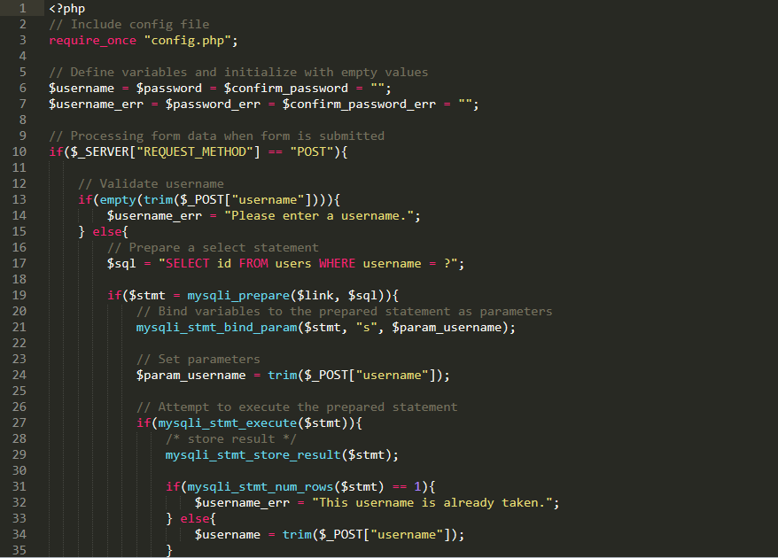

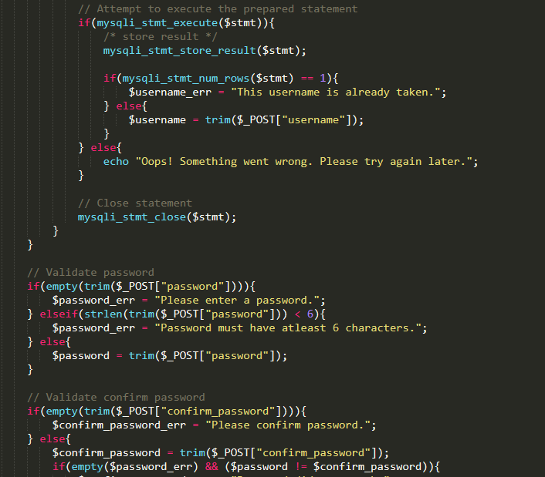

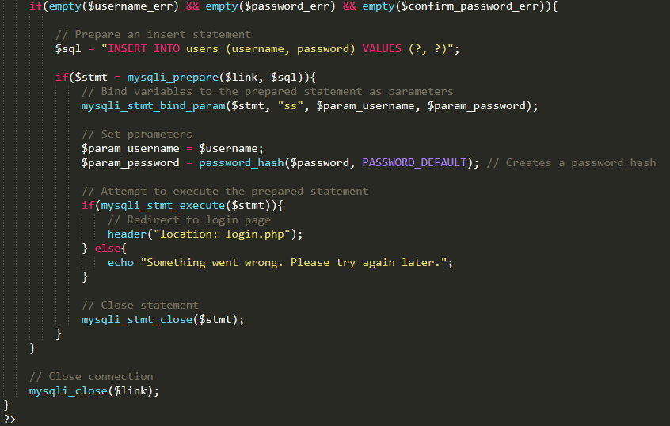

**Home Page:**

**Index.html**

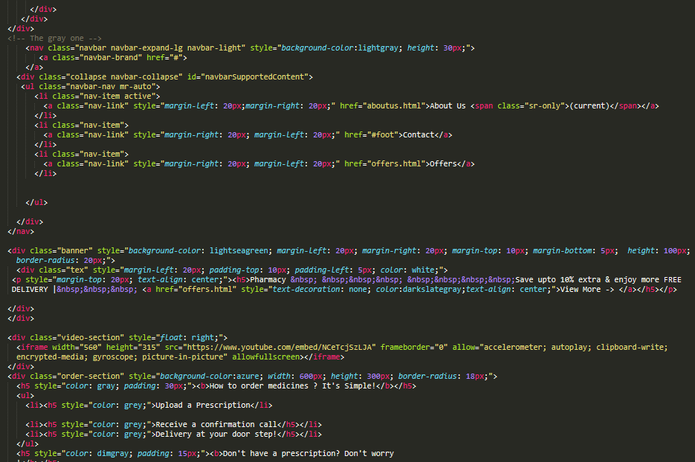

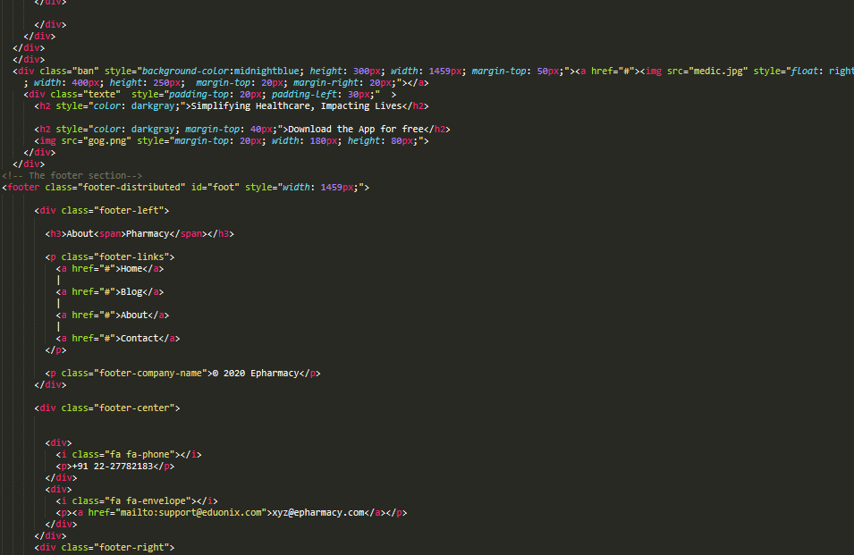

**HomeCare page**

**homecare.html**

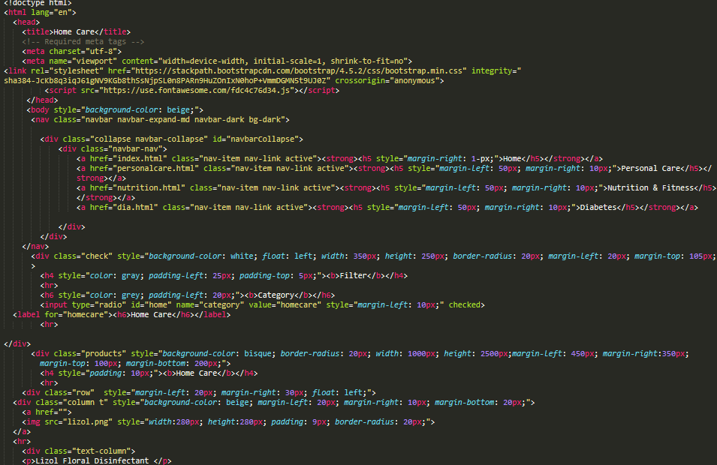

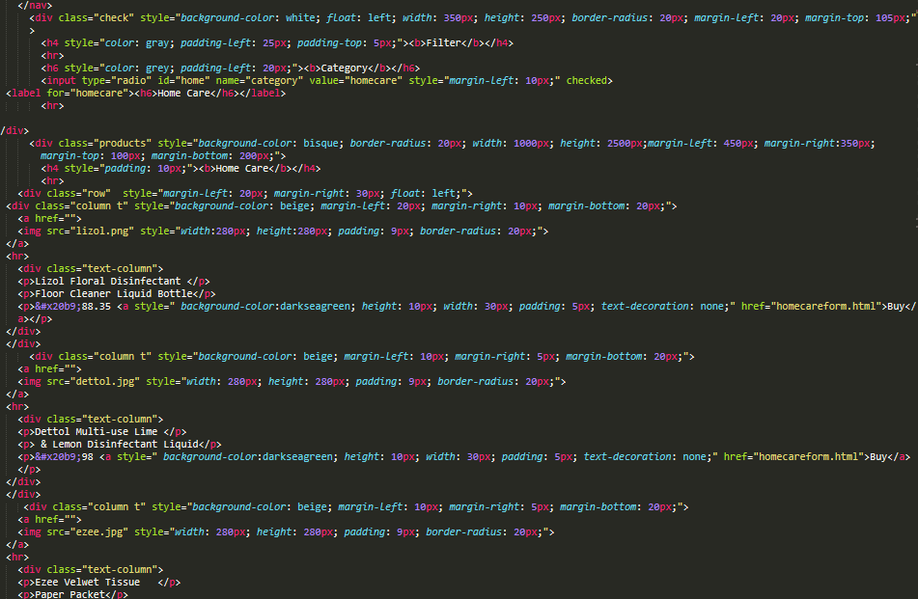

**Payment form**

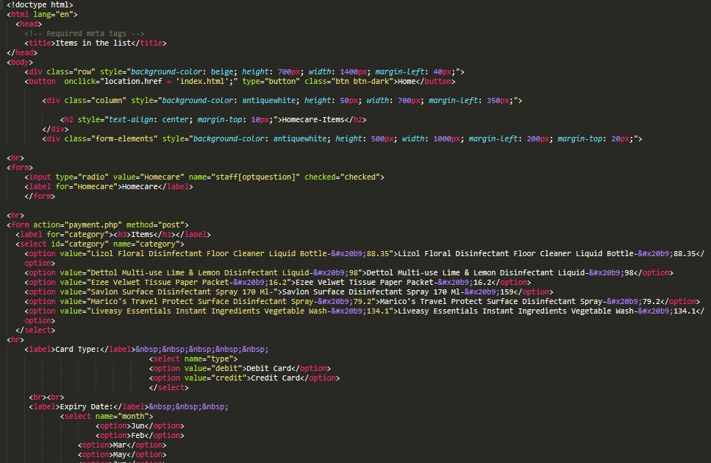

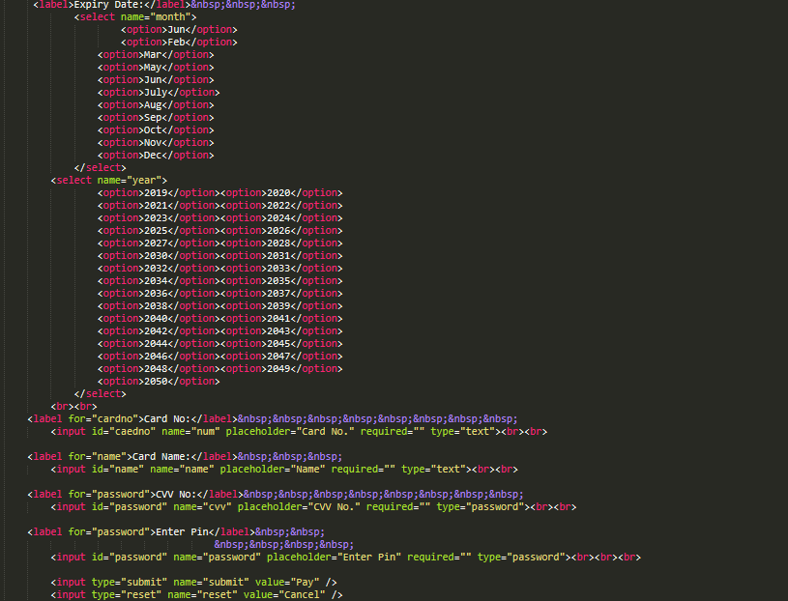

**Database Connectivity**

**phpMyAdmin**

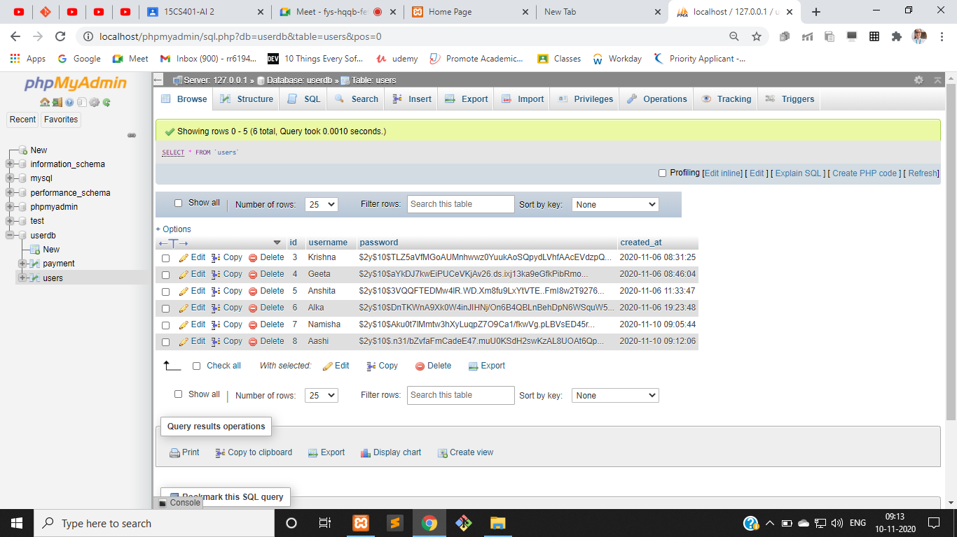

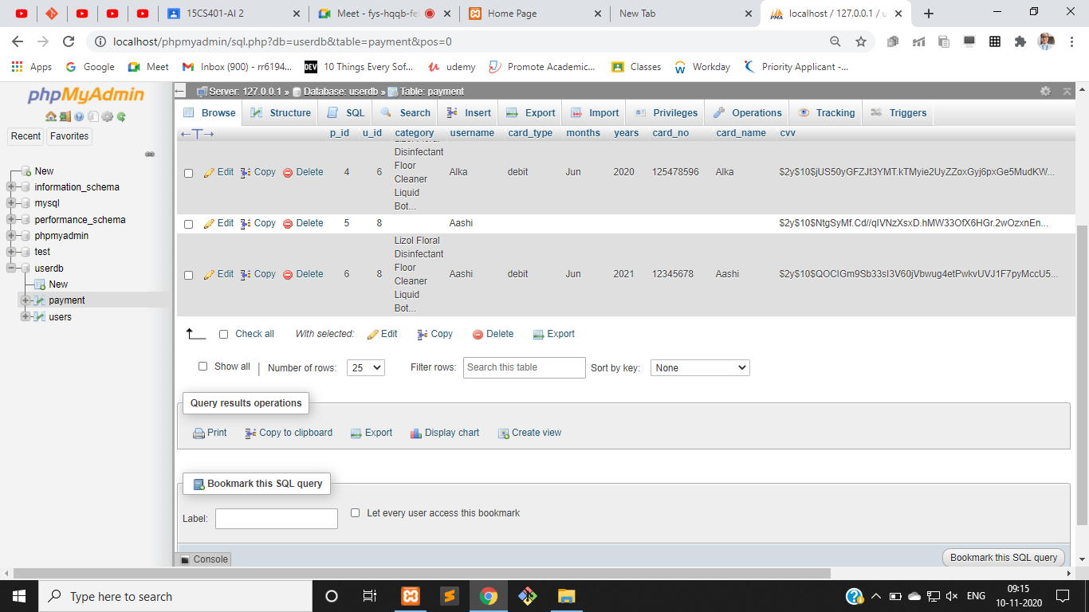

**Screenshots from Project**

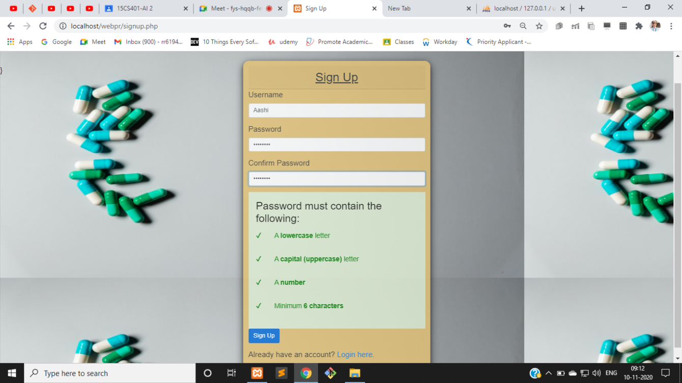

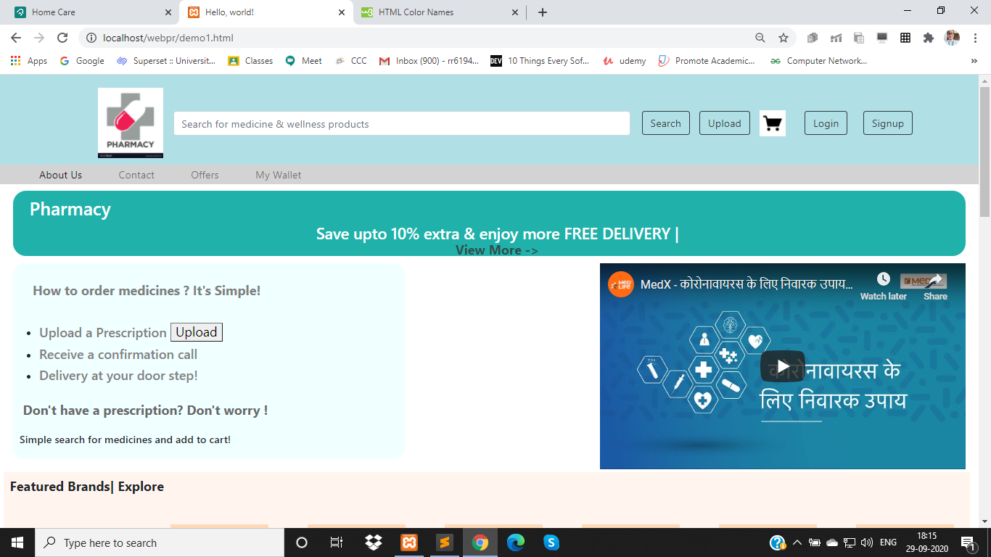

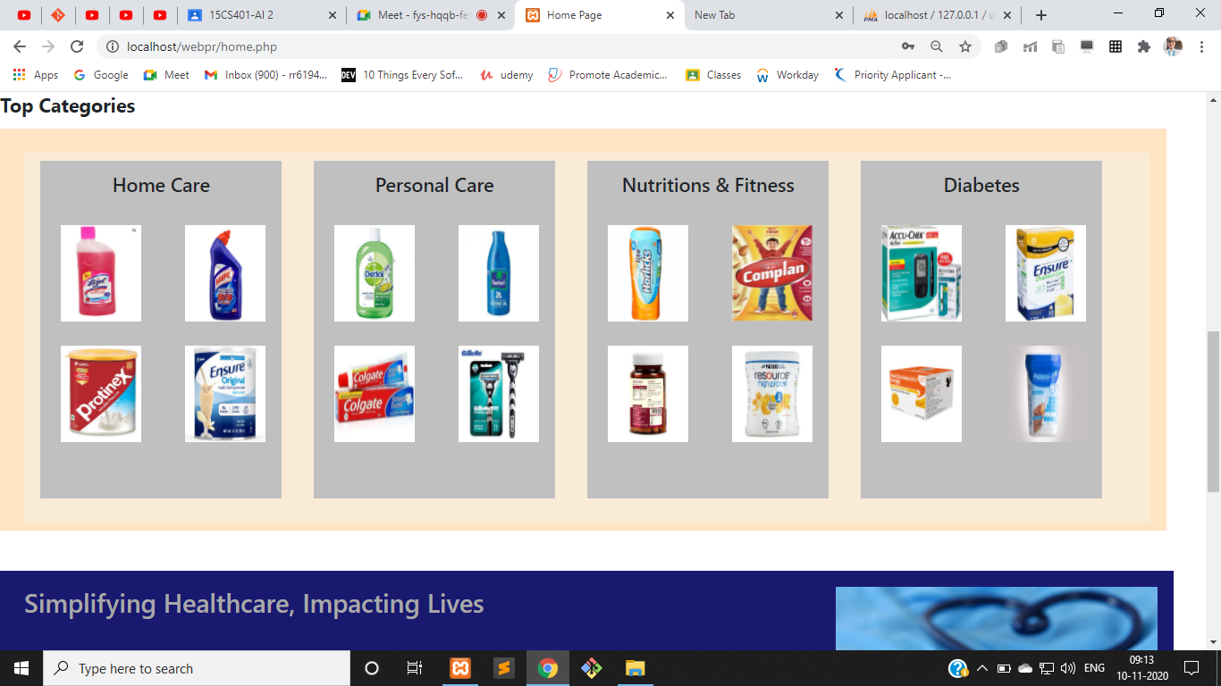

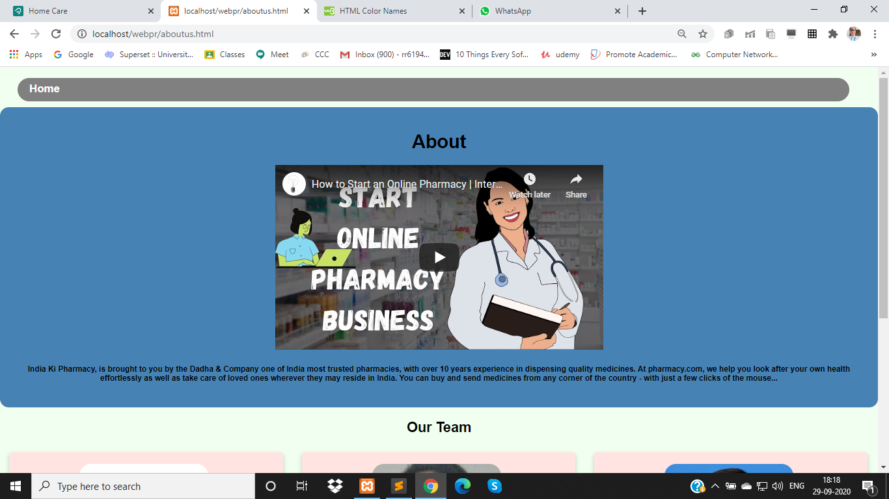

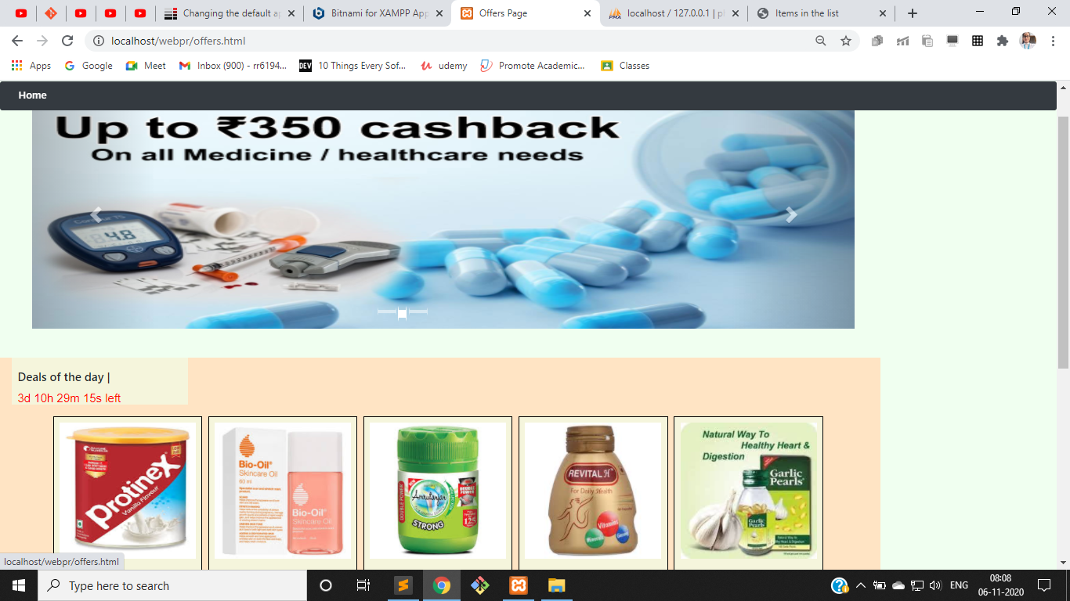

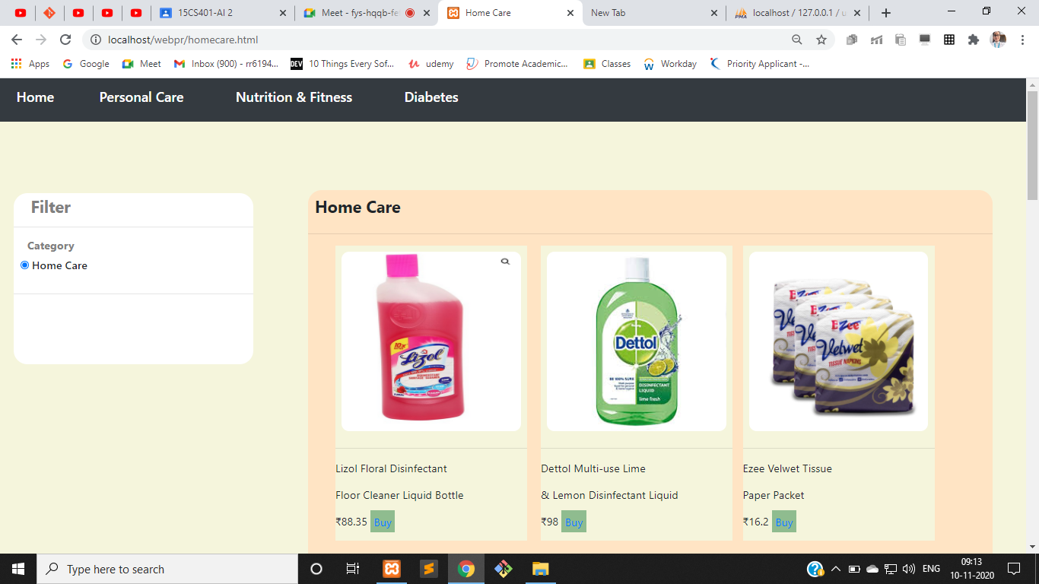

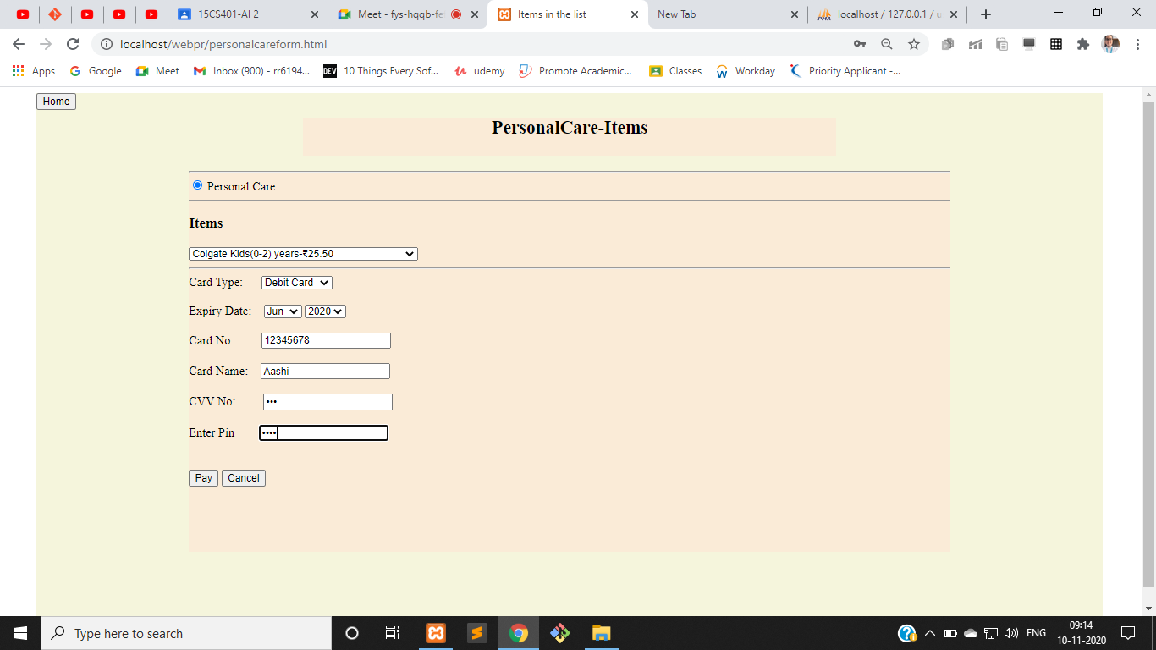

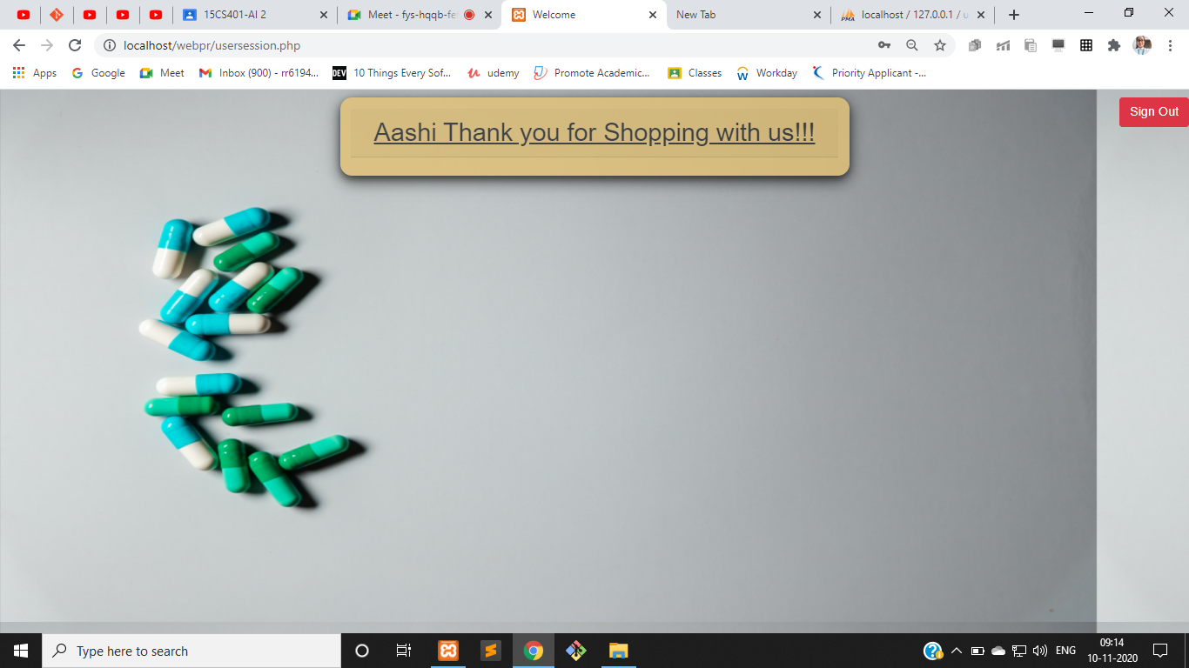

**Database :**



This is how details are updated in the database.

**Conclusion:**

Since the project was mainly based on placing orders online, a database was created which holds all details of all customers, and when they place order it is also reflected in the database. This is helpful as it incorporates all the details that are required.

The project mainly focuses on the front and back-end implementation.

**Future Work:**

The future work focuses on making the website more functional , and also improving over the user interface.

Working extensively over the back-end and also making it more smooth.

**References:**

1.www.w3schools.com

2. [www.youtube.com](https://www.youtube.com/channel/UCBR8-60-B28hp2BmDPdntcQ)

3.www.stackoverflow.com

4.www.tutorialspoint.com